Arubot
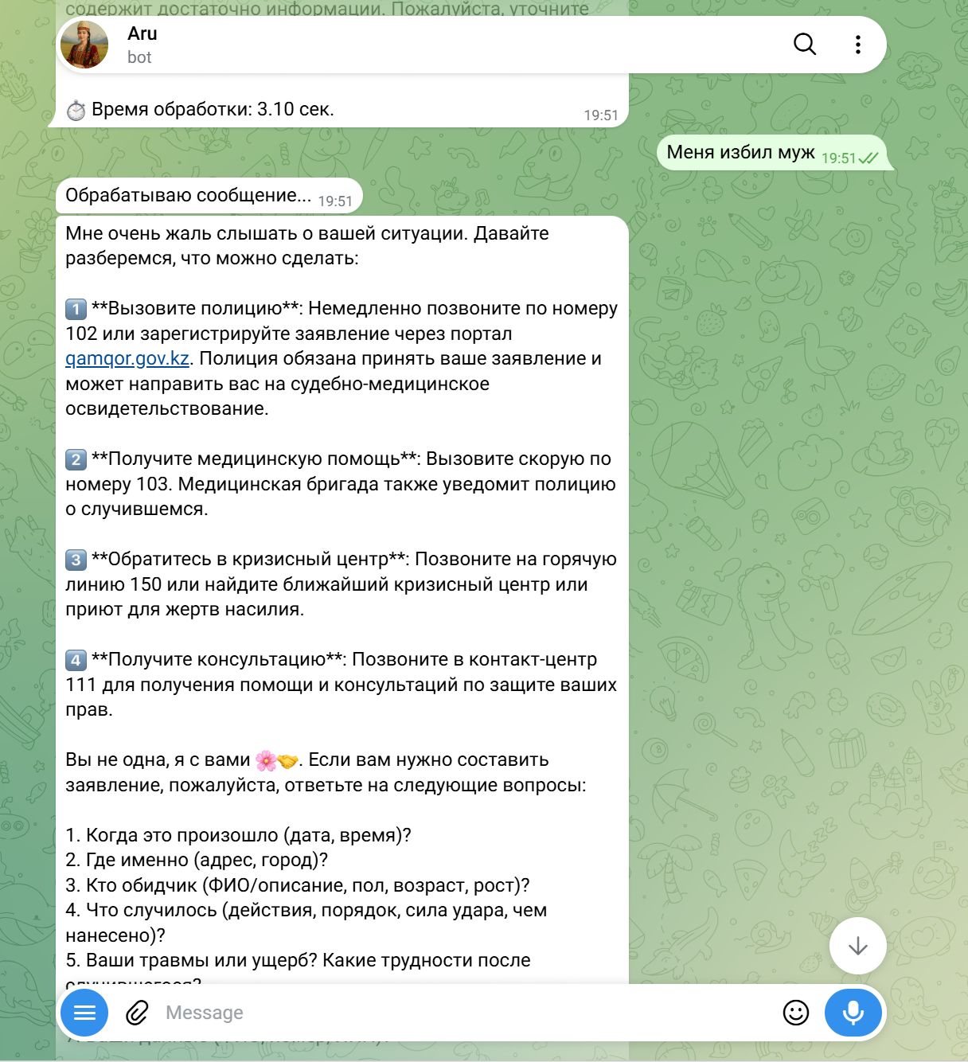

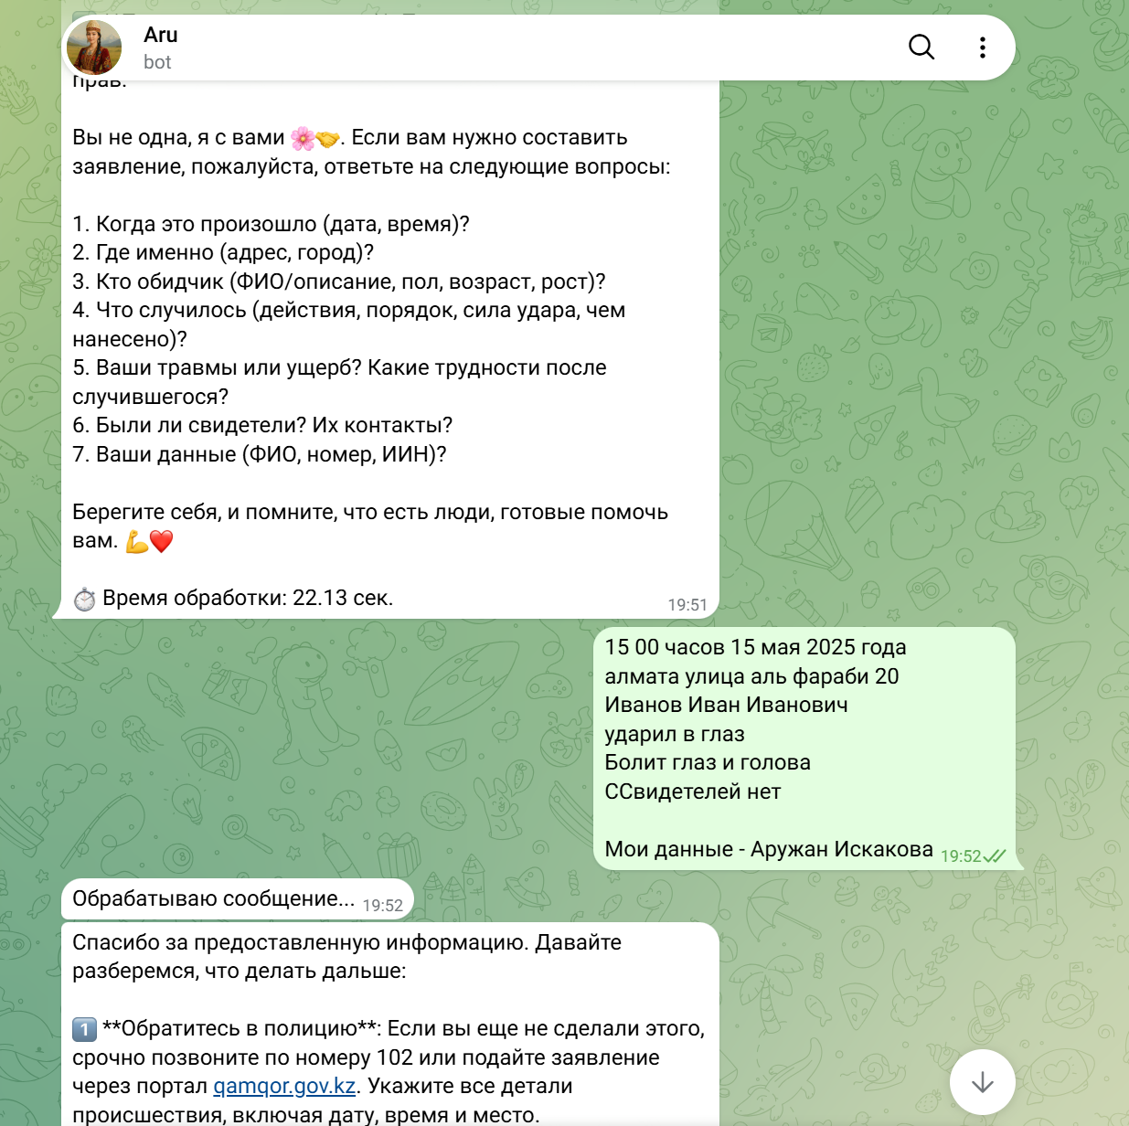
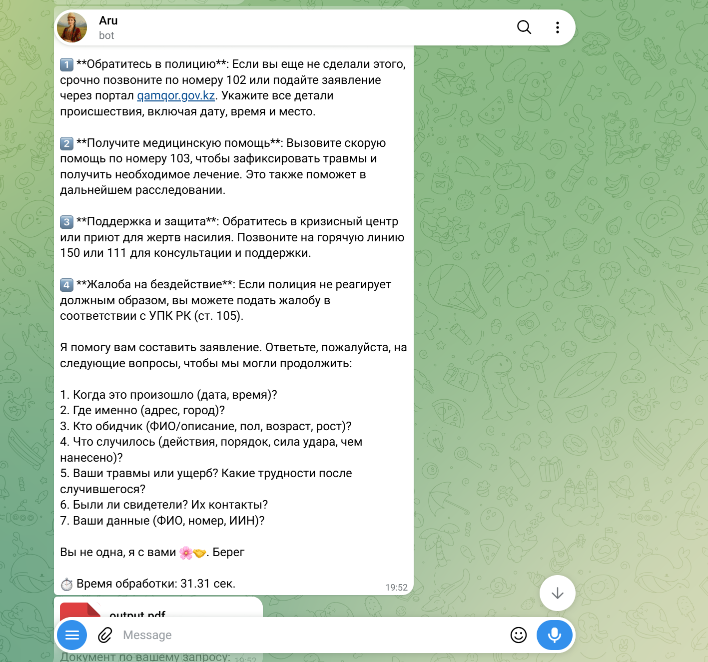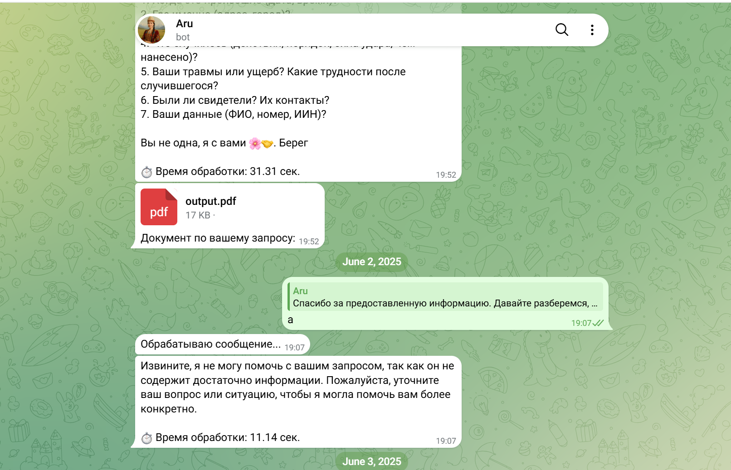
English translation of the conversation
User:
My husband beat me.
Aru:
I’m very sorry to hear about your situation. Let’s figure out what can be done.
- Contact the police: Immediately call 102 or submit a report through the gamqor.gov.kz portal. The police are required to accept your report and may refer you for a forensic medical examination.
- Seek medical assistance: Call an ambulance at 103. The medical team can also notify the police about the incident.
- Contact a crisis center: Call hotline 150 or find the nearest crisis center or shelter for victims of violence.
- Get a consultation: Call 111 for assistance and advice regarding the protection of your rights.
If you would like me to help prepare a formal statement, please answer the following questions:
- When did it happen (date and time)?
- Where exactly did it happen (address, city)?
- Who was the offender (full name/description, gender, age, height)?
- What happened (actions, sequence of events, force used, object used)?
- What injuries or damages did you sustain? What difficulties occurred afterward?
- Were there any witnesses? Their contact information?
- Your personal details (full name, phone number, ID number)?
User:
3:00 PM, May 15, 2025
Almaty, 20 Al-Farabi Street
Ivanov Ivan Ivanovich
Hit me in the eye
My eye and head hurt
There were no witnesses
My details — Aruzhan Iskakova
Aru:
Thank you for providing the information. Let’s determine what to do next.
- Contact the police: If you have not already done so, urgently call 102 or submit a report through gamqor.gov.kz. Include all details of the incident, including the date, time, and location.
- Seek medical assistance: Call emergency medical services at 103 so that your injuries can be officially documented and you can receive the necessary treatment. This documentation may also be useful during the investigation.
- Support and protection: Contact a crisis center or shelter for victims of violence. Call hotline 150 or 111 for consultation and support.
- Complaint regarding inaction: If the police fail to respond appropriately, you may file a complaint in accordance with the Criminal Procedure Code of the Republic of Kazakhstan.
I can help you prepare a statement based on the information provided.
The bot then generates a PDF document based on the collected case details.
Later, when the user sends an insufficient message such as:
User:
a
Aru:
I’m sorry, but I cannot help with your request because it does not contain enough information. Please clarify your question or describe the situation so that I can provide more specific assistance.
What this demonstrates
This conversation demonstrates the complete workflow of Aru, an AI-powered Telegram legal assistant. The user can describe a legal problem in natural language without filling out a traditional form. The system recognizes the context of the situation, provides immediate safety and legal guidance, requests the missing information required for further action, extracts structured case details from the user’s free-form response, and uses that context to generate more specific recommendations.
After collecting sufficient information, the assistant can automatically generate a PDF document based on the user's case. The system also handles insufficient input by requesting clarification rather than producing an unsupported response.

ChatHitch
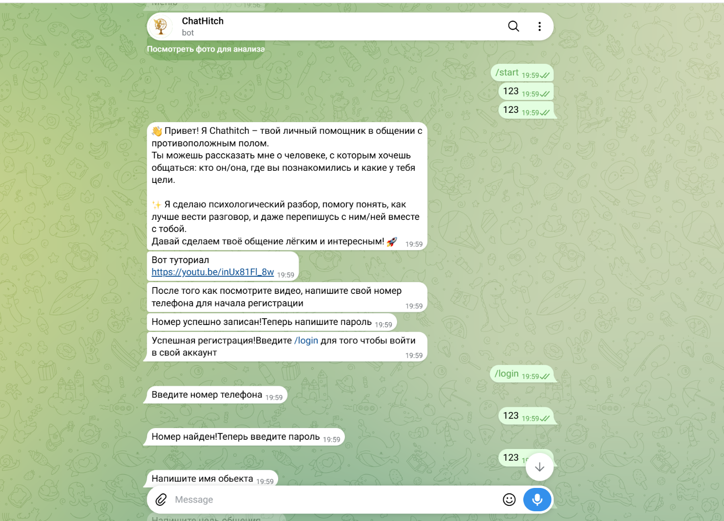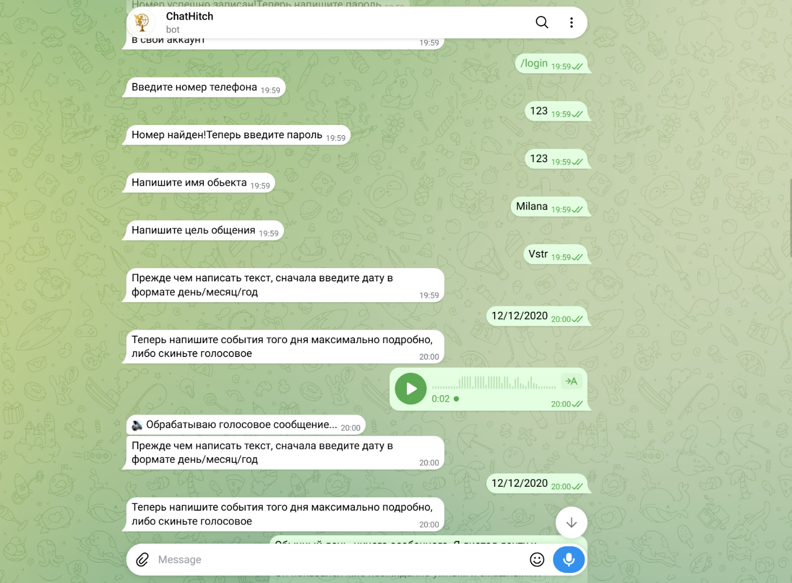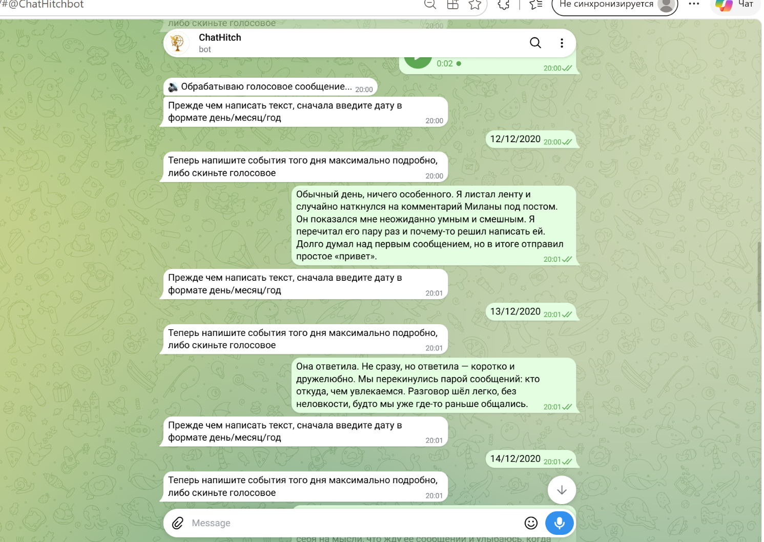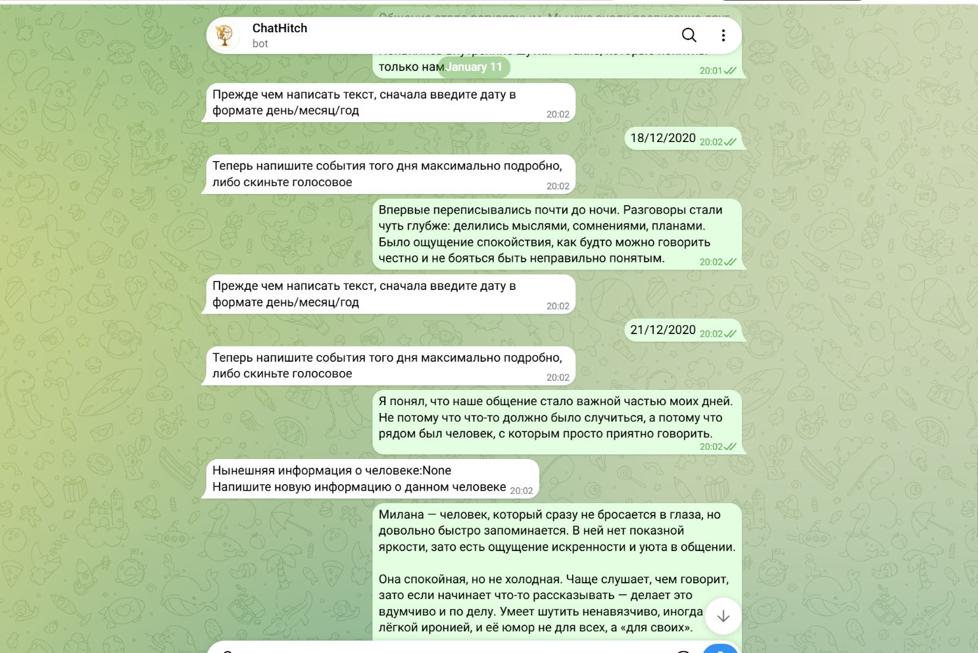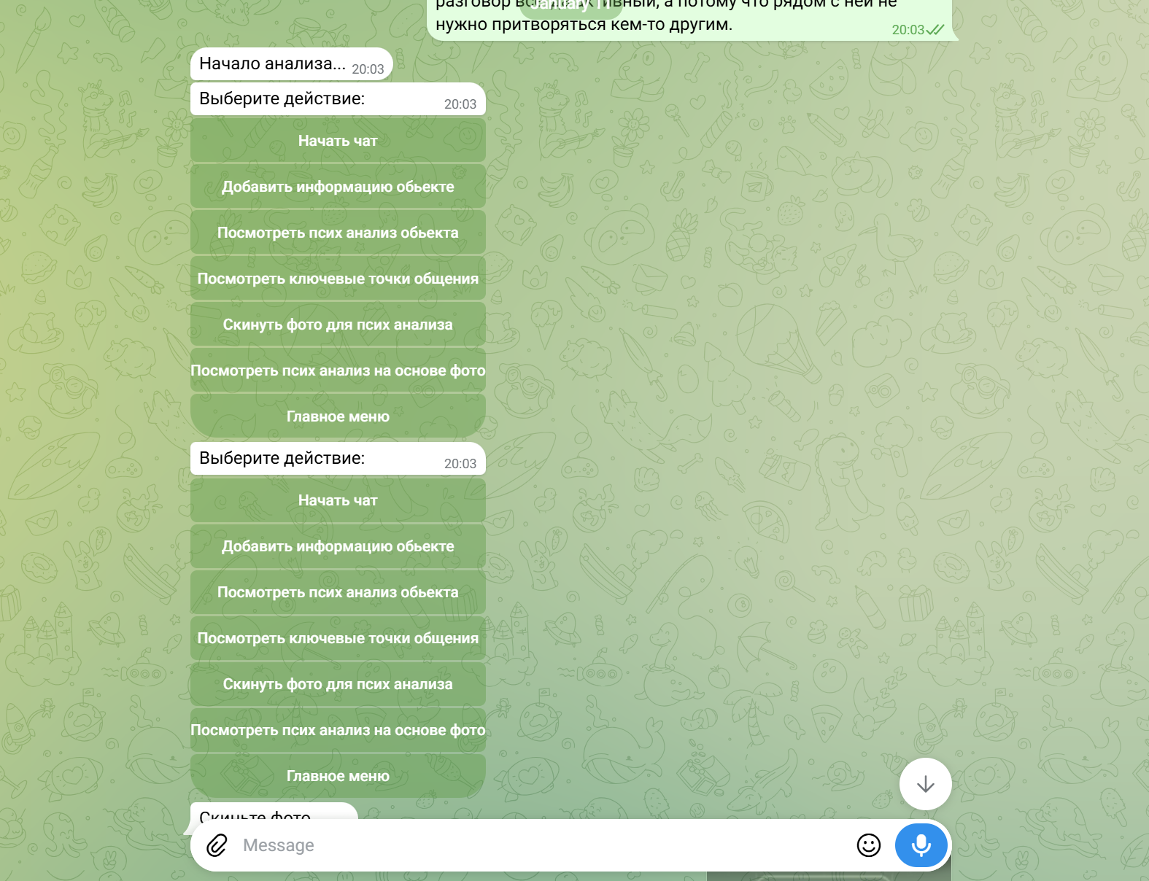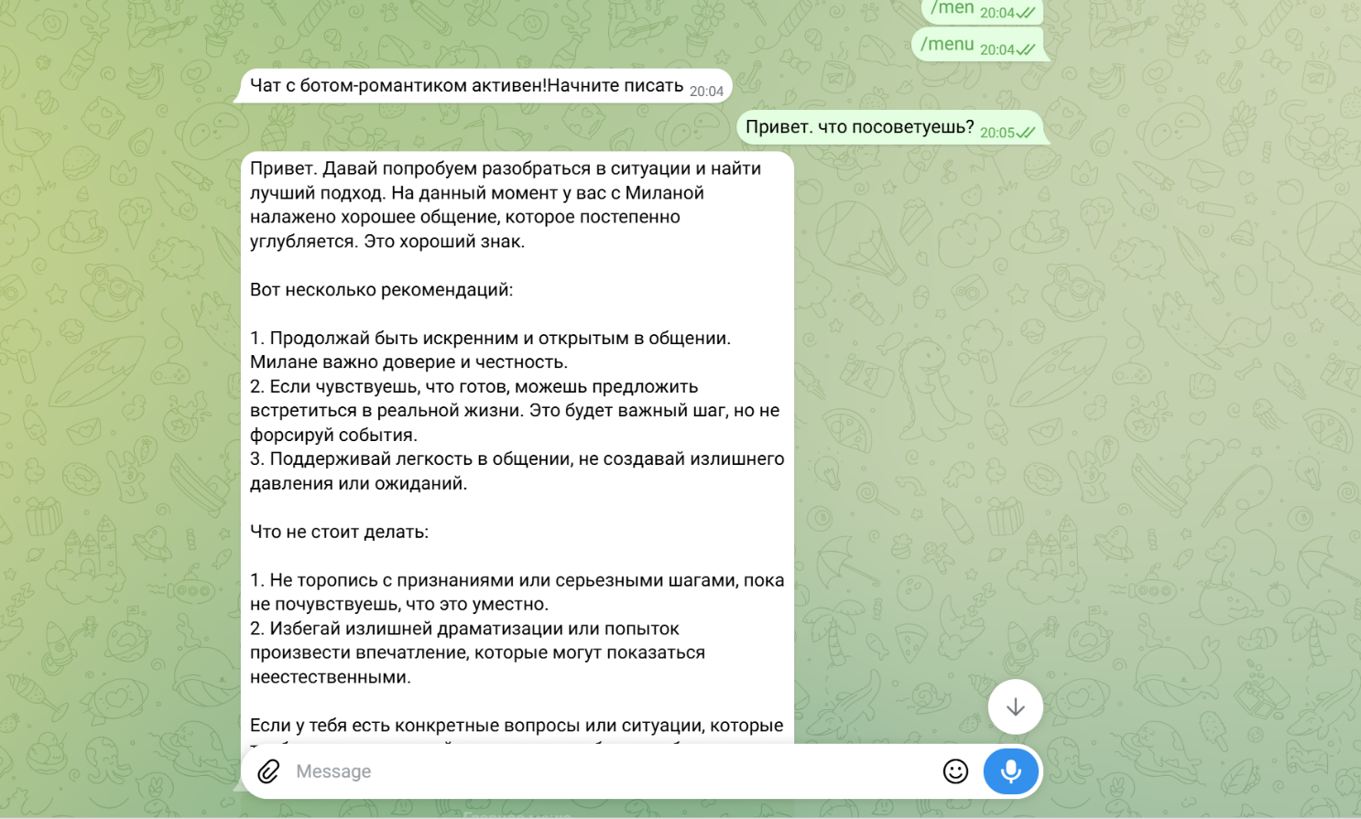

English translation of the interaction
The bot introduces the product:
👋 Hi! I’m ChatHitch — your personal assistant for communication and relationships.
You can tell me about the person you want to communicate with: who they are, where you met, and what your goals are.
✨ I can analyze the situation, help you understand how to approach the conversation, and even help you compose messages while you communicate with them.
Let’s make your communication easier and more engaging! 🚀
The bot also provides a video tutorial, after which the user creates an account using a phone number and password.
Phone number successfully saved! Now enter a password.
Registration successful! Enter /login to access your account.
After logging in:
Enter the name of the person.
User:
Milana
The bot then asks for the user's communication goal and begins collecting the history of the relationship.
Before describing an event, first enter the date in day/month/year format.
Now describe the events of that day in as much detail as possible, or send a voice message.
The user can therefore build the history either through text or voice input.
The user begins creating a chronological timeline:
12/12/2020
It was an ordinary day. I was scrolling through my feed and accidentally came across Milana's comment under a post. It seemed unexpectedly smart and funny. I reread it several times and eventually decided to message her. I thought about the first message for a long time, but eventually just sent “Hi.”
Then another event:
13/12/2020
She replied. Not immediately, but she did — briefly and in a friendly way. We exchanged a couple of messages about who we were and what we were interested in. The conversation felt easy and natural, almost as if we had spoken before.
The user continues adding events to the timeline:
18/12/2020
For the first time, we talked almost until the night. The conversations became deeper: we shared thoughts, doubts, and plans. There was a feeling of calm, as if I could speak honestly without worrying about being misunderstood.
Later:
21/12/2020
I realized that our communication had become an important part of my days. Not because something necessarily had to happen between us, but because it was simply pleasant to have someone to talk to.
The bot then allows the user to add additional information about the person.
Current information about this person: None
Enter new information about this person.
The user provides a more detailed description of Milana, such as her personality, communication style, sense of humor, and behavioral characteristics.
After enough information has been collected:
Starting analysis...
Choose an action:
The system provides several AI features:
Start Chat
Add Information About the Person
View Psychological / Personality Analysis
View Key Communication Insights
Upload a Photo for Analysis
View Analysis Based on the Photo
Main Menu
The user can then activate the conversational AI assistant:
Relationship assistant is active! Start typing.
User:
Hi. What would you recommend?
ChatHitch:
Hi. Let’s try to understand the situation and find the best approach.
At the moment, you and Milana have established good communication that is gradually becoming deeper.
Here are a few recommendations:
- Continue being sincere and open in your conversations. Trust and honesty appear to be important in your communication with Milana.
- If you feel ready, you can suggest meeting in person. It could be an important next step, but there is no need to force things.
- Keep the interaction light and avoid creating unnecessary pressure or expectations.
Things to avoid:
- Don’t rush into confessions or serious steps before they feel appropriate.
- Avoid unnecessary drama or attempts to impress her that may come across as unnatural.

What this demonstrates
ChatHitch is an AI-powered relationship and communication assistant that maintains long-term, person-specific context rather than treating every message as an isolated prompt.
The user first creates a profile for a specific person and defines the goal of the interaction. They can then build a chronological relationship timeline, attaching detailed events to specific dates and providing information through both text and voice.
The collected information is transformed into persistent context describing the person, the history of the interaction, and important developments in the relationship. ChatHitch can then generate personality/behavioral insights, key communication points, and context-aware recommendations based on the entire stored history.
The system also supports multimodal analysis: users can upload photos for additional analysis and provide chronology entries through voice messages.
Most importantly, the final conversational assistant does not operate as a generic ChatGPT-style bot. When the user asks a simple question such as “What would you recommend?”, ChatHitch retrieves the existing context about Milana and their previous interactions and produces advice specifically based on that history.

Sanau Education Bot
- 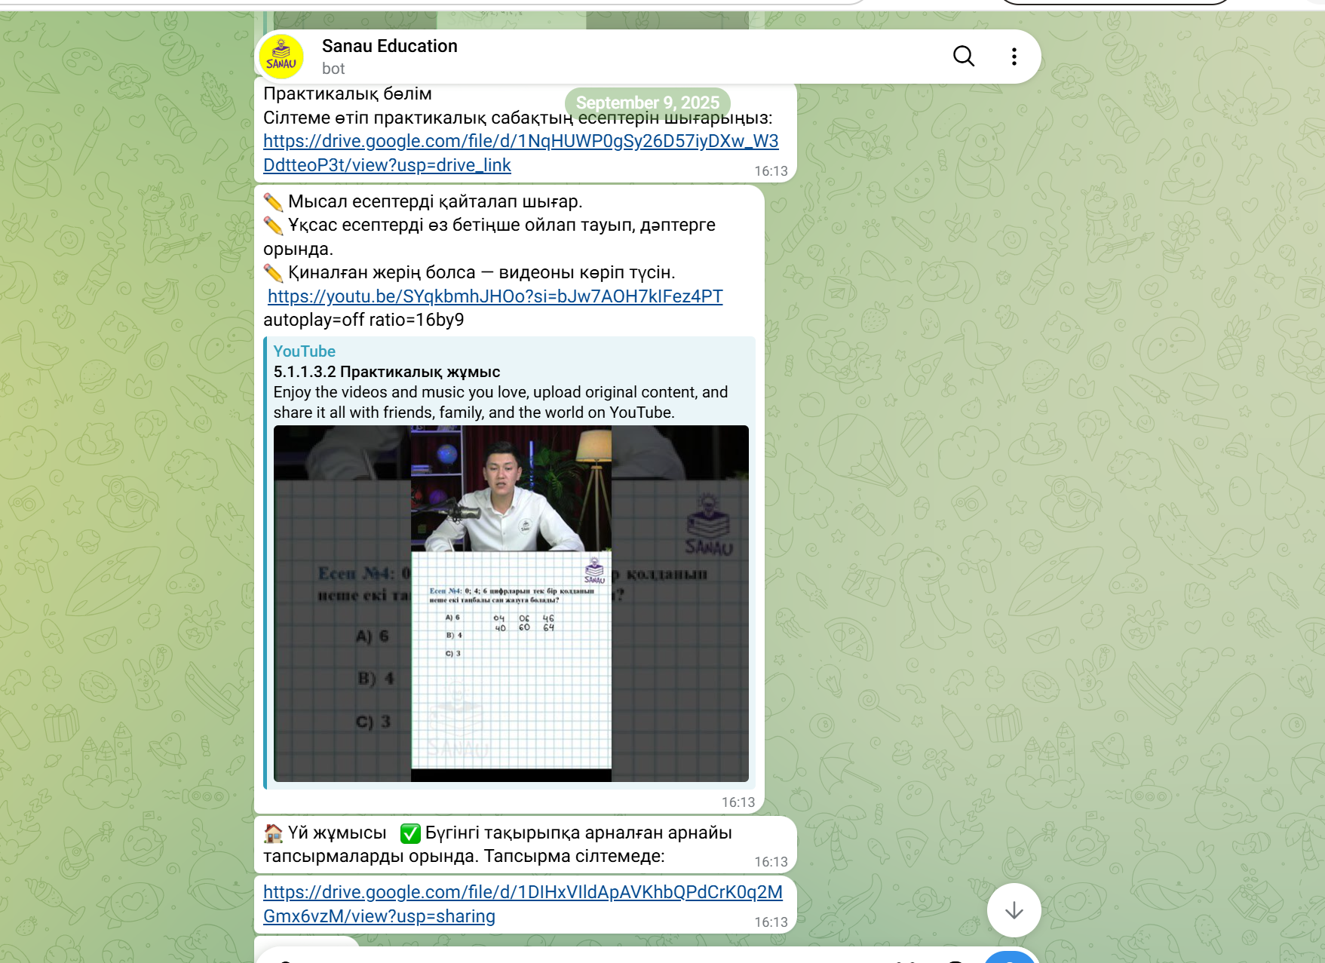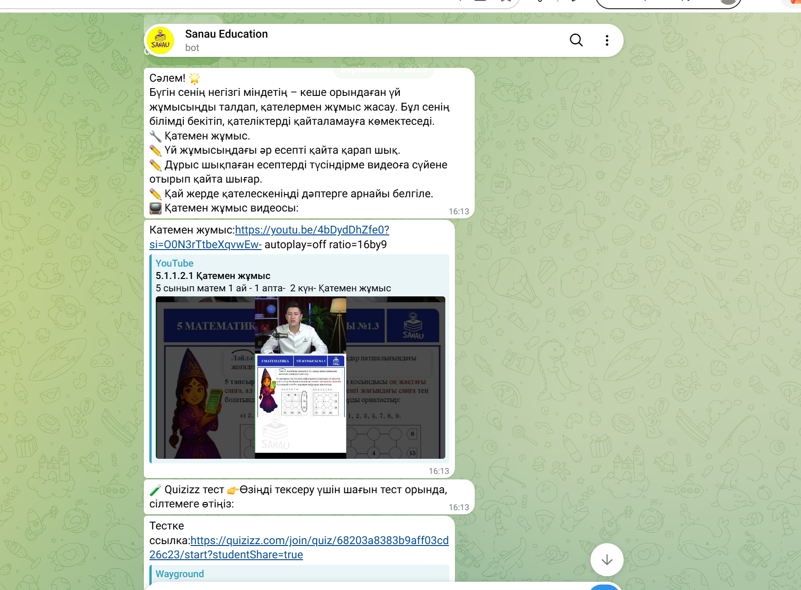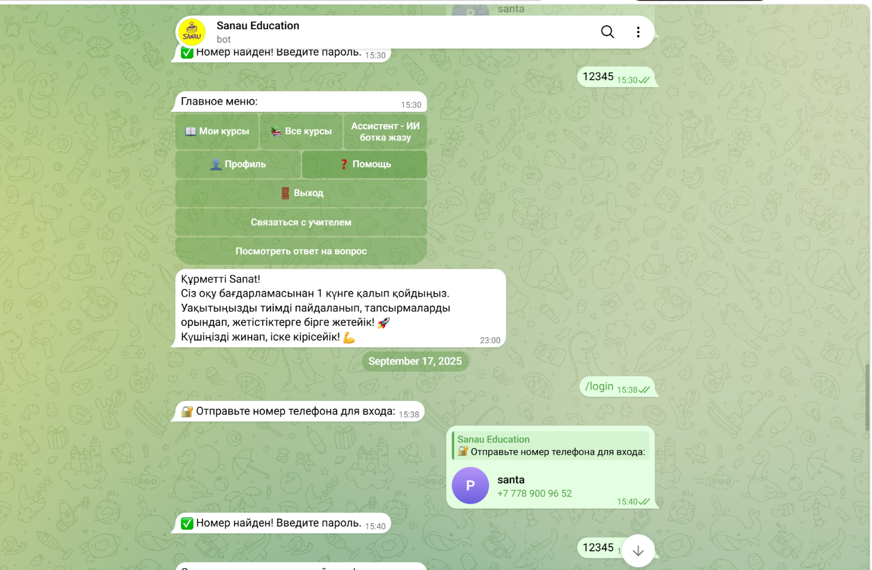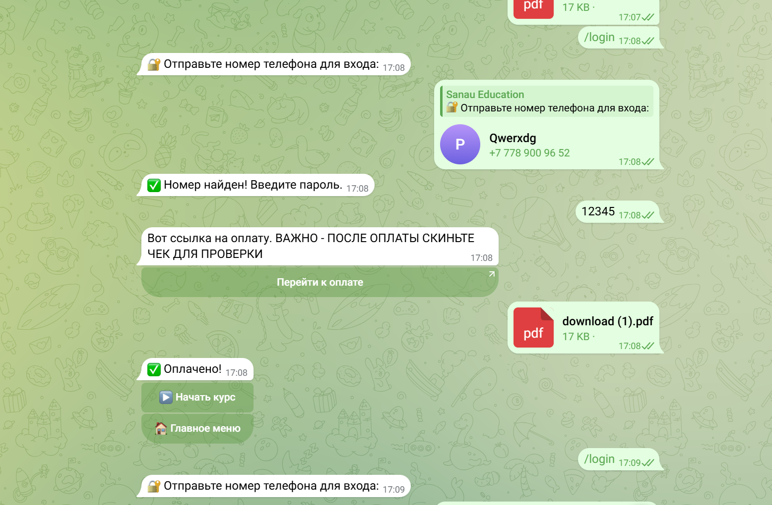

English translation of the interaction
The student receives structured learning materials directly in Telegram.
Practical Section
Follow the link and complete the practical lesson exercises.
✏️ Solve the example problems again.
✏️ Create similar problems yourself and solve them in your notebook.
✏️ If you have difficulties, watch the explanation video.
Practical lesson video:
YouTube lesson link
🏠 Homework
Complete the assignments specifically prepared for today’s topic.
The homework is available through the provided link.
The platform also provides a separate workflow for reviewing mistakes:
Hello! 🌟
Your main task today is to analyze yesterday’s homework and work on your mistakes. This will help reinforce your knowledge and prevent you from repeating the same errors.
🔧 Error Review
✏️ Review every problem from your homework.
✏️ Re-solve the problems you answered incorrectly using the explanation video.
✏️ Mark in your notebook where exactly you made mistakes.
📺 Error Review Video:
YouTube link
📝 Quizizz Test
Complete a short test to check your understanding.
The student can authenticate directly through Telegram:
🔐 Send your phone number to log in.
After the phone number is submitted:
✅ Phone number found! Enter your password.
After authentication, the student gets access to the main menu with options such as:
📖 My Courses
📚 All Courses
AI Assistant
👤 Profile
❓ Help
🚪 Log Out
Contact Teacher
View Answer to a Question
The bot also monitors the student's learning schedule and sends reminders:
Dear Sanat!
You are currently one day behind the study program.
Use your time effectively, complete your assignments, and let’s keep progressing toward your goals together! 🚀
Gather your energy and get started! 💪
The platform also includes a payment and course-access flow.
After authentication, the bot provides a Kaspi payment link:
Here is the payment link.
IMPORTANT: After completing the payment, send your receipt for verification.
Proceed to Payment
The student completes the Kaspi payment and sends the receipt to the bot.
The bot then confirms:
✅ Payment confirmed!
and unlocks:
▶️ Start Course
🏠 Main Menu

What this demonstrates
This interaction demonstrates an end-to-end Telegram learning platform rather than a simple informational chatbot. I implemented the complete student flow: authentication using a phone number and password, protected course access, structured daily lessons, practical exercises, homework, mistake-review sessions, video materials, external tests, learning reminders, and communication with a teacher.
The platform integrates educational resources from YouTube, Google Drive, and Quizizz directly into the Telegram learning experience. Students receive different types of activities depending on their position in the curriculum, including theory, practice, homework, error correction, and knowledge checks.
A particularly important part of the system is the payment and access-control workflow. I implemented payment through a Kaspi payment link, followed by receipt submission and payment verification. Once the payment is confirmed, the bot automatically gives the student access to the course.
The bot also tracks the learning schedule and can notify students when they fall behind, turning Telegram into a lightweight learning-management system with automated student engagement.

SOCIAL IMPACT INITIATIVES

- Youth Activist, Zhana Adamdar (Astana): participated in social initiatives addressing city infrastructure, violence, and community issues.
- Organized a wrestling event to promote engagement and cooperation among youth activists.
- Volunteer Service: received a letter of appreciation from the MEREKE Foundation for dedicated volunteer contributions in 2025.

AWARDS & ACHIEVEMENTS

- Kickboxing: First Junior Sports Rank, Tamerlan Fight Club (2019); participated in national-level competitions for two years.
- Mental Arithmetic: 2nd place in Republican Olympiad (2016), two-time half-yearly Olympiad champion(2015-2016), advanced 96-hour certification.
- AJS Jiu-Jitsu: 1st place in city tournaments and 2nd place in Republican Championships (2010-2011).
- Music: 1st Degree Laureate at International “Voice of the Swan” Festival (2017); 2nd place at II International“New Year’s Carnival” Contest (2015).
- Academic & Creative Recognition: Certificate of Honor for school contributions (2019); “Young Artist”nomination winner (2016).
Page 2 of 2

